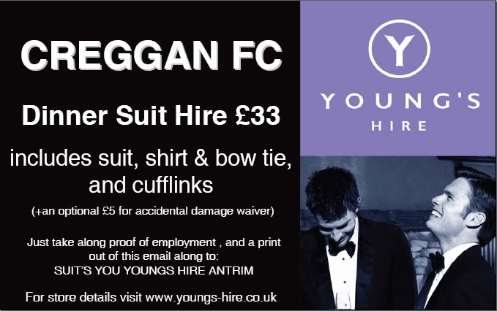

'Suits You' at Junction One (028 94469178) and 'Debonair' in Magherafelt (028 79634986) are offering a £5 discount on formal wear hire for the Gala Dinner. Say you are from Creggan and suit hire at Suits You will be discounted to £33, and £25 at Debonair.

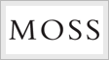

Moss in Junction One (028 94461205) are offering jacket, Trousers, Shirt, Cumberband & Bow Tie for £36 all in, including insurance.
Say you are for Creggan and you will get all the above for the listed price.

